VEHICLE EMERGENCY SUPPORT SYSTEM

PROJECT REPORT
SUBMITTED IN PARTIAL FULFILLMENT OF THE REQUIREMENTS
FOR THE
DEGREE OF BACHELOR OF TECHNOLOGY
IN
Department of Computer Science & Engineering
BY
NAME | Registration No: | Roll No:
PIJUSH DAS | 161420110029 | 14200116041
PRATIK GON | 161420110030 | 14200116040
ANONYO SANYAL | 161420110007 | 14200116063
PRATIK SATPATHY | 161420110032 | 14200116038

Under the Supervision
of
Dr. Sutirtha Kumar Guha, Associate Professor


DEPARTMENT OF Computer Science & Engineering
MEGHNAD SAHA INSTITUTE OF TECHNOLOGY
Techno Complex, Madurdaha, Beside NRI Complex, post-Uchhepota, Kolkata-700150
Affiliated by

JUNE 2020

CANDIDATE’S DECLARATION

I hereby declare that the work which is being presented in the project entitled “VEHICLE EMERGENCY SUPPORT SYSTEM” in fulfillment of requirements for the award of degree of B.Tech. in CSE, submitted in the Department of Computer Science & Engineering at MEGHNAD SAHA INSTITUTE OF TECHNOLOLY under MAULANA ABUL KALAM AZAD UNIVERSITY OF TECHNOLOGY, KOLKATA is an authentic record of our own work carried out during Session 2019-2020 under the supervision of Dr. Sutirtha Kumar Guha . The matter presented in this project has not been submitted by us in any other University / Institute for any award.

_________________________
Signature of the Students
With Date


Nazirabad, P.O. :Utchepota, Via Sonarpur, Kolkata 700 150

CERTIFICATE
This is to certify that the Project entitled “Vehicle Emergency Support System” is being submitted by Pijush Das, Pratik Gon, Anonyo Sanyal, Pratik Satpathy in partial fulfillment of the requirement for the award of the degree of B.Tech.in Computer Science and Engineering to the Department of Computer Science and Engineering, Meghnad Saha Institute of Technology, Kolkata, is a record of original work carried out by him under my guidance and supervision from __________ to __________

The results presented in this thesis have been verified and are found to be satisfactory. The results embodied in this thesis have not been submitted to any other University for the award of any other degree or diploma.

………………………………………
Dr. Sutirtha Kumar Guha
Associate Professor
Computer Science & Engineering
Meghnad Saha Institute of Technology
Kolkata-700150

________________________________
(Signature of the Project Guide)
Date:
Place:

Nazirabad, P.O. :Utchepota, Via Sonarpur, Kolkata 700 150

CERTIFICATE OF APPROVAL
The foregoing project entitled “Vehicle Emergency Support System” is hereby approved as a creditable study of an engineering subject carried out and presented in a manner satisfactory to warrant its acceptance as prerequisite for the degree for which it has been submitted. It is to be understood that by this approval the undersigned do not necessarily endorse or approve any statement made, opinion expressed or conclusion drawn therein but approve the thesis only for the purpose for which it has been submitted.

Project Guide __________________________

Head of the Department __________________________

Date:
Place:
[Departmental & College Seal]

Acknowledgement
Life as a researcher is a zig-zag way and has many ups and downs, but I overcome from them because of the support and faith of many individuals.
First and foremost, I would like to express my sincere gratitude to Dr. Sutirtha Kumar Guha for providing me an opportunity to work with him/her. Your creativity encouraged me, your energy and dedication towards work motivates me. Your perfection always inspired me to do things perfectly. I feel motivated and encouraged every time I attend your meeting. Without your encouragement, inspiration and guidance this thesis/dissertation would not have materialized. Thank you so much for not only guiding me in this thesis / dissertation but for every knowledge you give me. This thesis / dissertation is dedicated to your creativity and enthusiasm of doing work.
I wish to thank many people for their direct or indirect help in achieving this goal. Special thanks to my parents for their support and encouragement throughout my study, their faith in me ignite that spark to do anything for their happiness.
Last but not least I would like to thank all my friends for being with me at each step when I need their support. This thesis never be successful without your support and love.

_____________________
(Signature of the Students)
Pijush Das
Pratik Gon
Anonyo Sanyal
Pratik Satpathy
Abstract

When a car undergoes any on road issue like breakdown or accidents immediate assistance needs to be provided. The problem with the existing system is that it provides inefficient assistance. Mainly the assistance is provided by the Service stations directly. This in turn increases the load on the service stations which leads to many problems like wastage of time in waiting, increased cost due to more manpower, inefficiency etc. Our idea is to reduce this hassle and utilize the nearby resources available and reduce the pressure on the service station.

To do so we will use the idea of Edge Computing and map the idea of filtering useful data and sending them to the servers. Here we will filter according to the resources available and forward it according it to the service stations if none of them can solve.

In this project vehicles are presumed to be a part of an interconnected graph. Vehicles are considered as node of the graph. Different clusters are formed based on the similarity features of the vehicles. Request from a vehicle is processed and analyzed at the edge of the cluster. Edge computing concept is implemented to reduce the cloud overhead.
We are expecting a better outcome because of this approach.
Keywords. Vehicle Assistance System, Edge Computing, Cluster Networks, Automation

TABLE OF CONTENTS
Page No.

Abstract
List of Tables
List of Figures

Chapter 1. | Introduction …………………………………………………. | Page-5
 | - Objective ………………………………………………… | Page-5
 | - Domain Definition.………………………………...... | Page-5
 | - Motivation of Research................................................ | Page-6
Chapter 2. | Preliminaries …………………………………........................ | Page-7
 | 2.1. Edge Computing ……………………...………. | Page-7
 | 2.1.1 Application ………………….…. | Page-7
 | 2.2. External Application Tools Requirement.................... | Page-7
Chapter 3. | Literature Review...……………………………...............…… | Page-8
 | 3.1. An Edge Computing Tutorial ……………..…….....………. | Page-8
 | 3.2. Graph-Based Optimal Data Caching in Edge Computing…………… | Page-8
 | 3.3. Edge computing technologies for Internet of Things: a primer … | Page-8
 | 3.4. What is Edge Computing: The Network Edge Explained … | Page-9
 | 3.5. Mobile Edge Computing: Recent Efforts and Five Key Research Directions ……………..…….....………. | Page-9
 | 3.6. Edge of Things: The Big Picture on the Integration of Edge, IoT and the Cloud in a Distributed Computing Environment ……………..…….....………. | Page-10
 | 3.7. EdgeIoT: Mobile Edge Computing for the Internet of Things ……………..…….....………. | Page-11
 | 3.8. Quantifying the Impact of Edge Computing on Mobile ……………..…….....………. | Page-11
 | 3.9. Modelling the Intrusive feelings of advanced driver assistance systems based on vehicle activity log data: a case study for the lane keeping assistance system ……………..…….....………. | Page-11
 | 3.10. Advanced Driver-Assistance Systems: A Path Toward Autonomous Vehicles ……………..…….....………. | Page-12
 | 3.11. Road Assistance System Using GPS. ……………..…….....………. | Page-13
 | 3.12. A Car Breakdown Service Station Locator System. ……… | Page-13
 | 3.13. Safety driving assistance system design in intelligent vehicles……………..…….....………. | Page-14
 | 3.14. An Intelligent Driver Assistance System (I-DAS) for Vehicle Safety Modelling using Ontology Approach ……………..…….....………. | Page-14
Chapter 4. | Problem Formulation...……………………………..............… | Page-16
 | 4.1. Problem Statement ……………..…….....………. | Page-16
Chapter 5. | Proposed Work...……………………………..............… | Page-17
 | 5.1 Phase 1 ……………..…….....………. | Page-17
 | 5.2 Phase 2.....................……………......... | Page-19
 | 5.3 Phase 3.....................……………......... | Page-20
Chapter 6. | Experiments and Analysis...……………………………..............… | Page-22
 | 6.1. Experiment……………..…….....………. | Page-22
 | 6.2. Analysis.....................….....…......... | Page-25
Chapter 7. | Conclusion...……………………………..............… | Page-30
 | Reference...……………………………..............…

List of Figures
Figure Title Page
Figure 1 Proposed Phase-1 Network 17
Figure 2 Custer network among all the cars. 18
Figure 3 Proposed Phase-2 Network 19
Figure 4 Cluster Network of Cars and Service Car 20
Figure 5 Cluster Network of Car and Service station 21
Figure 6 Welcome Window 22
Figure 7 Instruction Window 22
Figure 8 View of Database with the highlighted JOD ID that is going to search 23
Figure 9 Select Problem Window 24
Figure 10 Output Window 24
Figure 11 Updated Database 25
Figure 12 Case wise segregation 25

CHAPTER 1. INTRODUCTION

  - Purpose

We all like a little get-away from the hustle and bustle of our daily lives of routine. Travelling is fun until some unexpected and unforeseen happens. In those dire situations what we need is easily, accessible, and reliable help. Services that are available in typical scenario are server-based support. Request is sent to the server and solution or support is provided by the server.
The assistance system that we use is highly dependent on the availability of service. The travelers in fact at times are not even aware of the available services nearby. The assistance provided to the travelers is nowadays achieved using GPS system. The traveler locates its location and finds the nearby assistance system using various Navigation Applications using GPS Maps.
It is obvious that large amount of requests results traffic congestion in server end. An number of requests would be analyzed and served at the edge of the network. A significant amount of time would be saved, and prompt remedial measure would be initiated.
There are multiple disadvantages of such systems like the traveler is completely unaware of the services that are available near to them. At times travelers are made to stay in a position where they get no assistance due to unavailability nearby. Especially, in case of any remote location it is very difficult to find reliefs nearby. In case of breakdown like no fuel, engine failure or tire puncture it becomes difficult for the user to reach the nearby relief center. Secondly speed of operations is also important. Because in case of severe moments the time that one has in hand is very precious. Each dying second is important. So, we must try to save them. Thus, we can use Edge Computing to help optimize the performance and speed of the system.

  - Domain Definition

The domain of the project is on Edge computing. Edge computing is any type of computer program that delivers low latency nearer to the requests. Edge computing broadly as all computing outside the cloud happening at the edge of the network, and more specifically in applications where real-time processing of data is required.
Cloud computing operates on big data while edge computing operates on "instant data" that is real-time data generated by sensors or users.
Though we are not thinking to use any edge devices but to apply the idea of edge computing in the real-world problem. The real-world problem is road assistance system. We will map the idea of edge computing to establish the solution to this problem. So effectively we are working on two domains at the same time i.e. Edge computing and smart vehicle assistance system.

  - Motivation

There are multiple disadvantages of previous systems like the traveler is completely unaware of the services that are available near to them. At times travelers are made to stay in a position where they get no assistance due to unavailability nearby. In case of any remote location it is very difficult to find reliefs nearby. Especially in late night the reliefs seem to be unavailable even though they exist. In case of severe accident, it becomes impossible for the passenger/driver to access his smart phone to reach out for help. In case of breakdown like no fuel, engine failure or tire puncture it becomes difficult for the user to reach the nearby relief center.
Secondly speed of operations is also important. Because in case of severe moments the time that one has in hand is very precious. Each dying second is important. So, we must try to save them. Thus, we can use Edge Computing to help optimize the performance and speed of the system.
In our case we are thinking to use the basic idea of filtering data at the edge of the network and sending only the useful data to the server. In the assistance system we are thinking to filter the number of cars that are sent to service stations due to technical or non-technical failures which lead in unoptimized service. We can make use of the nearby resources which are available at the site of the breakdown to reduce the pressure of work on the service stations.
Since the present systems that we use are highly unoptimized we face a lot of problem as service providers as well as customers. Like from the point of view of a service station it needs to install more service stations which is a costly affair. Man power increases. Accuracy of work reduces. Customer satisfaction reduces. From the point of view of a customer as we are trying to create an ecosystem among the cars the customers can serve others to better the experience.
Hence, we chose the domain of edge computing and smart vehicle assistance system as our domain.

2. PRELIMINARIES

  - Edge Computing

Edge computing is a distributed, open IT architecture that brings computation closer to the source of the data that available in local system by minimizing the amount of long-distance communication, instead of relying on the cloud at one of a dozen data centers to do all the work.
It features decentralized processing power, enabling mobile computing and Internet of Things (IoT) technologies.
To support needs today and tomorrow, computing power and storage is being inserted out on the network edge in order to lower data transport time and increase availability.

2.1.1. Applications

For many companies, the cost savings alone can be a driver towards deploying an edge-computing architecture. Companies that embraced the cloud for many of their applications may have discovered that the costs in bandwidth were higher than they expected.

Increasingly, though, the biggest benefit of edge computing is the ability to process and store data faster, enabling for more efficient real-time applications that are critical to companies.

2.2 External Application Tool Requirement

2.2.1. Java Swing for creating an application for simulating our idea.

2.2.2. Java JDBC driver to analyze our dataset which we considered.

3. SYSTEM LITERATURE REVIEW

  - An Edge Computing Tutorial [1]
- Author Name: Inés Sittón-Candanedo, Juan Manuel Corchado Rodríguez
- Year of Publication: 2019
- Work Summary: Edge Computing (EC) is an emerging technology that has made it possible to process the large volume of data generated by devices connected to the Internet, through the Internet of objects (IO). The article provides an introduction to EC and its definition. The integration of EC in those contexts would imply an optimization of the processes that are normally executed in a cloud computing environment, bringing considerable advantages. The main contribution of EC is a better preprocessing of the data collected through devices, before they are sent to a central server or the cloud.

  - Graph-Based Optimal Data Caching in Edge Computing [2]
- Author Name: Xiaoyu Xia, Feifei Chen, Qiang He, Guangming Cui, Phu Lai, Mohamed Abdelrazek, John Grundy, Hai Jin
- Year of Publication: 2019
- Work Summary: In an edge computing environment, edge servers are deployed at base stations to offer highly accessible computing capacities and services to nearby users. Data caching is thus extremely important in edge computing environments to reduce service latency. The optimal data caching strategy in the edge computing environment will minimize the data caching cost while maximizing the reduction in service latency. In this paper, we formulate this edge data caching (EDC) problem as a constrained optimization problem (COP), prove that the EDC problem is NP-complete, propose an optimal approach named IPEDC to solve the EDC problem using the Integer Programming technique, and provide a heuristic algorithm named LGEDC to find near-optimal solutions. We have evaluated our approaches on a real-world data set and a synthesized data set. The results demonstrate that IPEDC and LGEDC significantly outperform two representative baseline approaches.

  - Edge computing technologies for Internet of Things: a primer [6]
- Author Name: Yuan Ai, Mugen Peng, Kecheng Zhang
- Year of Publication: 2018
- Work Summary: With the rapid development of mobile internet and Internet of Things applications, the conventional centralized cloud computing is encountering severe challenges, such as high latency, low Spectral Efficiency (SE), and non-adaptive machine type of communication. Motivated to solve these challenges, a new technology is driving a trend that shifts the function of centralized cloud computing to edge devices of networks. Several edge computing technologies originating from different backgrounds to decrease latency, improve SE, and support the massive machine type of communication have been emerging. This paper comprehensively presents a tutorial on three typical edge computing technologies, namely mobile edge computing, cloudlets, and fog computing. In particular, the standardization efforts, principles, architectures, and applications of these three technologies are summarized and compared. From the viewpoint of radio access network, the differences between mobile edge computing and fog computing are highlighted, and the characteristics of fog computing-based radio access network are discussed. Finally, open issues and future research directions are identified as well.

  - What is Edge Computing: The Network Edge Explained [7]
- Author Name: Hamilton, Eric
- Year of Publication: 2018
- Work Summary: Like the metaphorical cloud and the Internet of Things, the edge is a buzzword meaning everything and nothing. Over the years, we’ve seen paradigm shifts in computing workloads, going from data centers to the cloud and from the cloud to the logical edge of networks.
At its simplest, that’s what edge computing is: the processing and analyzing of data along a network edge, closest to the point of its collection, so that data becomes actionable.
It’s how a Nest thermostat knows to adjust the temperature at a certain time, how an Alexa device tells you the weather forecast for the day or how a self-driving car doesn’t run over a pedestrian or hop a curb Grand Theft Auto style.

  - Mobile Edge Computing: Recent Efforts and Five Key Research Directions [8]
- Author Name: Tuyen X. Tran, Mohammad-Parsa Hosseini, and Dario Pompili
- Year of Publication: 2017
- Work Summary: In the past decade, we have witnessed Cloud Computing play as significant role for massive data storage, control, and computation offloading. However, the rapid proliferation of mobile applications and the Internet of Things (IoT) over the last few years has posed severe demands on cloud infrastructure and wireless access networks. Stringent requirements such as ultra-low latency, user experience continuity, and high reliability are driving the need for highly localized intelligence in close proximity to the end users. In light of this, Mobile Edge Computing (MEC) has been envisioned as the key technology to assist wireless networks with cloud computing-like capabilities in order to provide low-latency and context-aware services directly from the network edge.
Differently from traditional cloud computing systems where remote public clouds are utilized, the MEC paradigm is realized via the deployment of commodity servers, referred to as the MEC servers, at the edge of the wireless access network. Depending on different functional splitting and density of the Base Stations (BSs), a MEC server can be deployed per BS or at an aggregation point serving several BSs. With the strategic deployment of these computing servers, MEC allows for data transfer and application execution in close proximity to the end users, substantially reducing end-to-end (e2e) delay and releasing the burden on backhaul network. Additionally, MEC has the potential to empower the network with various benefits, including: (i) optimization of mobile resources by hosting compute-intensive applications at the network edge, (ii) pre-processing of large data before sending it (or some extracted features) to the cloud, and (iii) context-aware services with the help of Radio Access Network (RAN) information such as cell load, user locations, and radio resource allocation.

  - Edge of Things: The Big Picture on the Integration of Edge, IoT and the Cloud in a Distributed Computing Environment [10]
- Author Name: El-Sayed H., Sankar S., Prasad M., Puthal D., Gupta A., Mohanty M. and Lin C.T.
- Year of Publication: 2017
- Work Summary: A centralized infrastructure system carries out existing data analytics and decision-making processes from our current highly virtualized platform of wireless networks and the Internet of Things (IoT) applications. There is a high possibility that these existing methods will encounter more challenges and issues in relation to network dynamics, resulting in a high overhead in the network response time, leading to latency and traffic. In order to avoid these problems in the network and achieve an optimum level of resource utilization, a new paradigm called edge computing (EC) is proposed to pave the way for the evolution of new age applications and services. With the integration of EC, the processing capabilities are pushed to the edge of network devices such as smart phones, sensor nodes, wearables, and on-board units, where data analytics and knowledge generation are performed which removes the necessity for a centralized system. Many IoT applications, such as smart cities, the smart grid, smart traffic lights, and smart vehicles, are rapidly upgrading their applications with EC, significantly improving response time as well as conserving network resources. Irrespective of the fact that EC shifts the workload from a centralized cloud to the edge, the analogy between EC and the cloud pertaining to factors such as resource management and computation optimization are still open to research studies. Hence, this paper aims to validate the efficiency and resourcefulness of EC. We extensively survey the edge systems and present a comparative study of cloud computing systems. After analyzing the different network properties in the system, the results show that EC systems perform better than cloud computing systems.
  - EdgeIoT: Mobile Edge Computing for the Internet of Things [11]
- Author Name: Nirwan Ansari, Xiang Sun
- Year of Publication: 2016
- Work Summary: In order to overcome the scalability problem of the traditional Internet of Things architecture (i.e., data streams generated from distributed IoT devices are transmitted to the remote cloud via the Internet for further analysis), this article proposes a novel approach to mobile edge computing for the IoT architecture, edgeIoT, to handle the data streams at the mobile edge. Specifically, each BS is connected to a fog node, which provides computing resources locally. On the top of the fog nodes, the SDN-based cellular core is designed to facilitate packet forwarding among fog nodes. Meanwhile, we propose a hierarchical fog computing architecture in each fog node to provide flexible IoT services while maintaining user privacy: each user's IoT devices are associated with a proxy VM (located in a fog node), which collects, classifies, and analyzes the devices' raw data streams, converts them into metadata, and transmits the metadata to the corresponding application VMs (which are owned by IoT service providers). Each application VM receives the corresponding metadata from different proxy VMs and provides its service to users. In addition, a novel proxy VM migration scheme is proposed to minimize the traffic in the SDNbased core.

  - Quantifying the Impact of Edge Computing on Mobile Applications [12]
- Author Name: Wenlu Hu, Ying Gao, Kiryong Ha, Junjue Wang
- Year of Publication: 2016
- Work Summary: Computational offloading services at the edge of the Internet for mobile devices are becoming a reality. Using a wide range of mobile applications, we explore how such infrastructure improves latency and energy consumption relative to the cloud. We present experimental results from WiFi and 4G LTE networks that confirm substantial wins from edge computing for highly interactive mobile applications.

  - Modelling the Intrusive feelings of advanced driver assistance systems based on vehicle activity log data: a case study for the lane keeping assistance system [14]
- Author Name: Kyudong Park, Jiyoung Kwahk, Sung H. Han, Minseok Song, Dong Gu Choi, Hyeji Jang, Dohyeon Kim, Young Deok Won, In Sub Jeong
- Year of Publication: 2019
- Work Summary: Although the automotive industry has been among the sectors that best-understands the importance of drivers' affect, the focus of design and research in the automotive field has long emphasized the visceral aspects of exterior and interior design. With the adoption of Advanced Driver Assistance Systems (ADAS), endowing 'semi-autonomy' to the vehicles, however, the scope of affective design should be expanded to include the behavioral aspects of the vehicle. In such a 'shared-control' system wherein the vehicle can intervene in the human driver's operations, a certain degree of 'intrusive feelings' are unavoidable. For example, when the Lane Keeping Assistance System (LKAS), one of the most popular examples of ADAS, operates the steering wheel in a dangerous situation, the driver may feel interrupted or surprised because of the abrupt torque generated by LKAS. This kind of unpleasant experience can lead to prolonged negative feelings such as irritation, anxiety, and distrust of the system. Therefore, there are increasing needs of investigating the driver's affective responses towards the vehicle's dynamic behavior. In this study, four types of intrusive feelings caused by LKAS were identified to be proposed as a quantitative performance indicator in designing the affectively satisfactory behavior of LKAS. A metric as well as a statistical data analysis method to quantitatively measure the intrusive feelings through the vehicle sensor log data.
- Limitation of Work: This system is providing an assistance to driver to avoid unpleasant situation through Lane Keeping Assistance system (LKAS) but not giving any assistance after unwanted situation occurred. It is actually improving the drivability of the vehicle.

  - Advanced Driver-Assistance Systems: A Path Toward Autonomous Vehicles [15]
- Author Name: Vipin Kumar Kukkala,Jordan Tunnell,Sudeep Pasricha,Thomas Bradley
- Year of Publication: 2018
- Work Summary: Advanced driver-assistance systems (ADASs) have become a salient feature for safety in modern vehicles. They are also a key underlying technology in emerging autonomous vehicles. State-of-the-art ADASs are primarily vision based, but light detection and ranging (lidar), radio detection and ranging (radar), and other advanced-sensing technologies are also becoming popular. In this article, we present a survey of different hardware and software ADAS technologies and their capabilities and limitations. We discuss approaches used for vision-based recognition and sensor fusion in ADAS solutions. We also highlight challenges for the next generation of ADASs
- Limitation of Work: ADAS is a system to improve driver-assistance for safety in the vehicle. But it failed to provide assistance if unpleasant situation occurred on the road.

  - Road Assistance System Using GPS. [16]
- Author Name: Miss. K. Iswarya, Miss. D. Devaki, Mr. E. Ranjith
- Year of Publication: 2017
- Work Summary:
The Road Assistance application was developed with the aim of providing emergency road side assistance services round the clock to ensure a pleasurable and uninterrupted journey virtually anywhere. The application is designed to enhance the user experience and ensure that users get immediate and hassle-free service in the event of any vehicle breakdown. Our application shall make all possible efforts to locate and direct the nearest service provider to user’s location. The application doesn’t just assure a prompt service in the rare event of a car breakdown, but it also helps with the mechanical breakdown towing, fuel delivery, flat tire change and car collision etc. The application helps you to find your nearby service centers as well as the fuel stations in case of emergency situations like insufficient fuel on vehicles and un-avoided incidents like puncture, break failure, doping etc. The exact locations with the distance from your place with the directions using Google Maps let you to know with ease to access with the help of this application on your smart mobiles.
- Limitations of work:
This particular system helps you by providing the location of the service centers and fuel stations in case of emergency situation rather than providing the necessary assistance to handle the situation. In case of severe accident, it becomes impossible for the passenger/driver to access his smart phone to reach out for help. In case of breakdown like no fuel, engine failure or tire puncture it becomes difficult for the user to reach the nearby relief center. In these kinds of scenario this system failed to provide required assistances to overcome the problem.

  - A Car Breakdown Service Station Locator System. [17]
- Author Name: Khoo Jin Sheng, Ahmad Suhaimi Baharudin, Kamal Karkonasasi
- Year of Publication: 2016
- Work Summary:
A lot of people are facing difficulties getting help when their car breaks down on the road. Many of them do not have any Car Repair Service Providers’ contact number and could not get help as the Car Repair Service Providers might be far away from their locations. These problems are the motivations for the development of this project to help those who are in need when their car breaks down along the roads. This project will start with the analysis of the car breakdown incidents on the road. It expects that through some research, the statistics of car breakdowns can be obtained to see if this project is helpful to those in need. The next step would be an analysis and comparison of those existing Car Breakdown Service portals or applications to identify the flaws. Development of a Car Breakdown Service Station Locator System will be carried out after planning and analysis. Internal testing and user testing of the application will be carried out before the system is being deployed. As part of the expected results, the proposed system connects Car Repair Service Providers (CRSP) and the Public through this system. If the car owner's transportation breaks down on any highway or federal road in any part of Malaysia, the owner could enter information with regards to the place of breakdown in the system using mobile phone, tablets. The system will automatically search for any CRSP nearest to the reported incident spot. The users are able to contact the CRSP to service the vehicle. This project aims to develop a Car Breakdown Service Station Locator System. The proposed system connects Car Repair Service Providers (CRSP) and the Public through this system. Keyword: Car Repair Service Providers, Car Breakdown, Car Breakdown Service Station Locator System in
- Limitation of Work:
This system providing a good connection to service station but it is unable to provide any on road assistance. Not only that it assigns each problem to the service station without checking it through any fellow car or service car. In some cases it becomes impossible for the passenger/driver to access his smart phone to reach out for help.

  - Safety driving assistance system design in intelligent vehicles [19]
- Author Name: Yimin Zhou,Gang Wang,Guoqing Xu,Guoqiang Fu
- Year of Publication: 2014
- Work Summary: In this paper, it discusses the state-of-art of the assistant safety driving technologies. It mainly includes the lane departure warning, ambient vehicle detection and vehicle safety distance keeping, pedestrian detection, driver behavior monitoring, vehicle motion control and communication. In the human-vehicle interaction, the large amount of information from all kinds of sensors should be well organized so that it can be used to assist driving, improve safety, avoid distraction and enjoy entertainment. The design of human-vehicle interface is also discussed.
- Limitation of Work: This system improve the safety measures of the vehicles but wouldn’t provide any assistance to overcome any broke down situation on the road .

  - An Intelligent Driver Assistance System (I-DAS) for Vehicle Safety Modelling using Ontology Approach [20]
- Author Name: Saravanan Kannan, Arunkumar Thangavelu, RameshBabu Kalivaradhan
- Year of Publication: 2010
- Work Summary: This paper proposes an ontology modelling approach for assisting vehicle drivers through safety warning messages during time critical situation. Intelligent Driver Assistance System (I-DAS) is a major component of in VANET, which focuses on generating the alert messages based on the context aware parameters such as driving situations, vehicle dynamics, driver activity and environment. I-DAS manages the parameter representation, consistent update /maintenance in XML format while the interpretation of a critical situation is done using ontology modelling. Related safety technologies such as Adaptive Cruise Control, Collision Avoidance System, Lane Departure Warning System, Driver Drowsiness detection system, Parking Assistance System, which generate warnings and alerts to driver continuously, for assistance according to context which is integrated in Vehicle and Vehicle 2 Driver (V2D) communications by DVI(Driver Vehicle Interface) had been applied. The simulation test bed developed using Java framework to generate safety alerts in various driving situations shows the usefulness of this approach. The response time graph for the simulation of context IDAS is depicted and analysed. The effective performance of the driving scenarios in various modes like day and night for single, 2-way and 4-way road scenario for the best, worst and average cases of simulation had been studied. The system works in VANET scenario, which needs to be adaptive for environment changes and to vary according to the context. The presented approach shows the simulation that can be implemented to all vehicles in real time scenario with promising results.

- Limitation of Work: I-DAS helps driver by generating different kind of alerts and warnings to avoid any kind of collision and unpleasant occurrence. But it doesn’t help to overcome any uncertain situation that can be occurred any time any where in the middle of the road.

4. PROBLEM FORMULATION

4.1 Problem Statement

Day by day the number of vehicles is increasing on the road at the same time the number of accidents is also increasing. If something unpleasant situation occurred all people tries to reach the service station for the assistance at the same time. For that reason, in an instance of time the workload over the service station getting higher that’s why they are failing to service and giving assistance all the car at the same time.
If we want all cars get service at a time, then we need to setup a greater number of service station which is not a cost-efficient process. Moreover, giving assistance to all break down cars at the same instance of time is also very inefficient process as service station must reach to all the cars so they need to cover different length of distances, which is time consuming as well as not fuel efficient.

5. PROPOSED WORK

In this work an automated emergency vehicle support system is introduced. Unexpected breakdown of vehicles would be entertained in most optimal way in highway. In our proposed system request from effected car would be generated first and then it would be attained at different levels. We consider three types of entities for solving the issues namely, Car, Service Car and Service Station.
The existing system needs to be automated for the benefit of the user. We propose a 3-phase system for supporting the cars in case of emergency. Initially effected car will go through phase-1 for support, if it does not get the help it will go to next phase.
In phase-1 neighbor car will be communicated. Phase-2 comprises of service car support. Phase-3 needs intervene of service station.

  - Phase-1
Cars would be connected with each other using bus topology concept so that each car will be connected to each other as shown in figure 1.

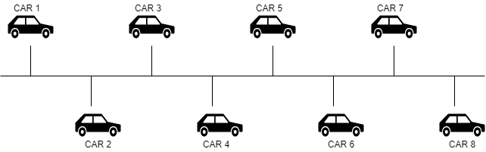

Figure 1. Proposed Phase-1 Network

Generated network of neighbor cars would be small in size for better communication and support to each other in case of emergency.
The car that needs help will act as a hub or head of the cluster. In other words, the bus network of cars turns into a cluster network with the effected car as hub as shown in figure 2. Hub car now triggers distress signals to the nearby cars. Process will be successfully terminated when neighbor car in the cluster is found to be able to provide the assistance to the effected car.
In case of unsuccessful process or in other words no neighbor car is capable enough to solve issue, Phase-2 will be activated. In that case a cluster among the effected car and the service cars would be constructed.

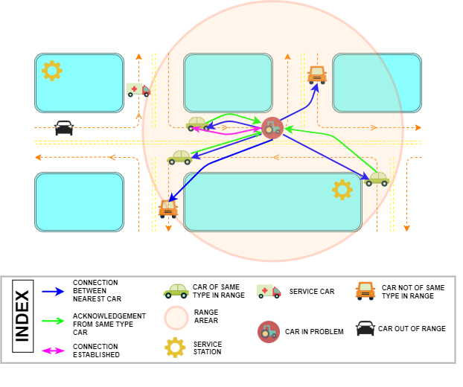
Figure 1. Custer network among all the cars.

5.2 Phase-2

In Phase-2 service car would be introduced in the network. Each car of the network would be connected with the service car using star topology concept as shown in figure 3.

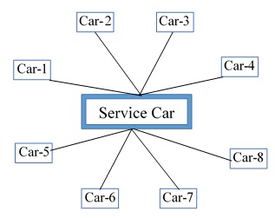
Figure 3. Proposed Phase-2 Network

The network would be converted into a cluster as shown in figure 4. In the cluster stressed car will act as cluster head and will produce distress signal. Process will be successfully terminated when service car in the cluster is found to be able to provide the assistance to the effected car.
In case of unsuccessful process or in other words service car is not able to solve issue, Phase-3 will be activated. In that case a cluster among the effected car and the service stations would be constructed.

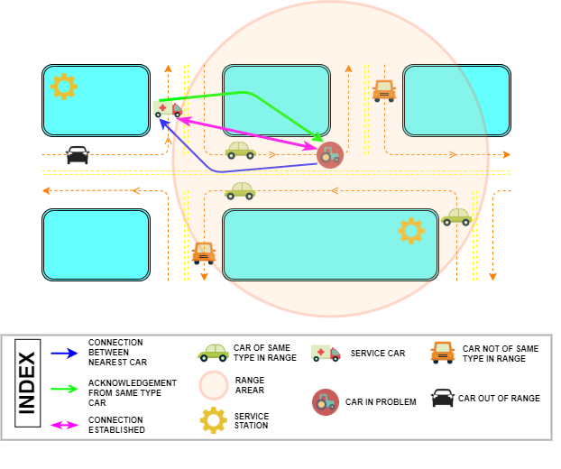
Figure. 4 Cluster Network of Cars and Service Car

  - Phase-3
In Phase-3 service station would be accessed by the affected car. As the issue remains unsolvable by the neighbor cars or service car, it would be escalated to the service station. A cluster would be constructed with affected car as the cluster head as shown in figure 5. Service station would be selected based on the possible quick response time.

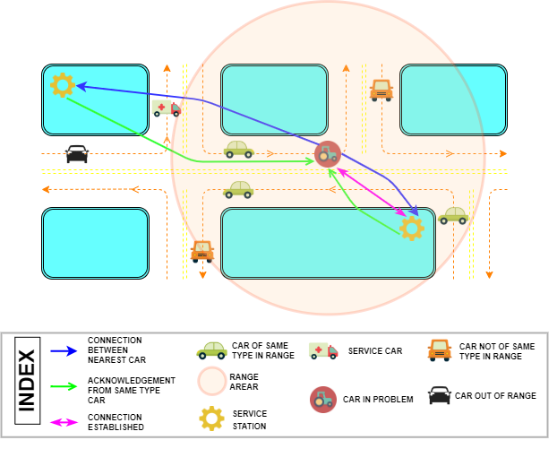
Figure. 5 Cluster Network of Car and Service station

Car issues would initially be handled by the passing by cars. Unsolved issues would be directed to service cars. Finally service station would be contacted for the issues that are not resolved at initial two phases. This proposed method reduce the load on work station, minimize the time delay for work station response even for a repair that would easily be handled by passing cars.
Issues are analyzed and filtered at the network level without sending the entire issues into the ‘cloud’ in terms of service station. Hence the concept of edge computing is implemented here to minimize the cost in terms of human resource and fuel consumption.

6. EXPERIMENTS AND ANALYSIS

6.1 Experiment
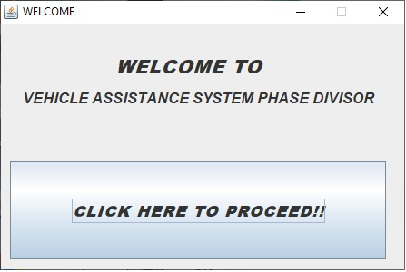
In this section, our proposed edge computing-based assistance system is implemented on a dataset. The result is compared with conventional assistance method where issues are directed and processed at corresponding service centre in terms of time and distance travelled. Our proposed method is implemented using C language on a Notebook PC with CPU 2 GHZ.

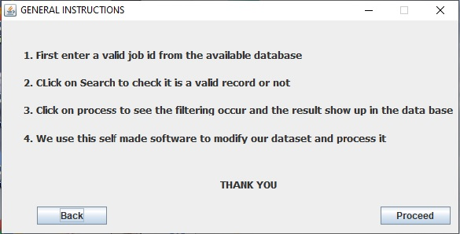

Figure 6: Welcome Window

Figure 7: Instruction Window
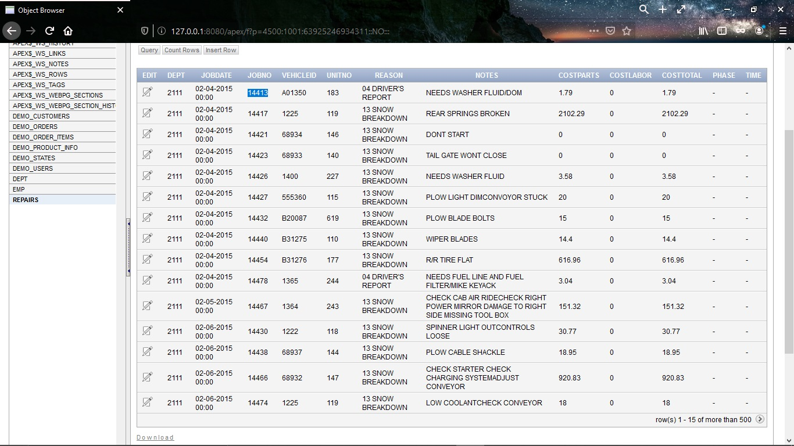
Figure 8: View of Database with the highlighted JOD ID that is going to search
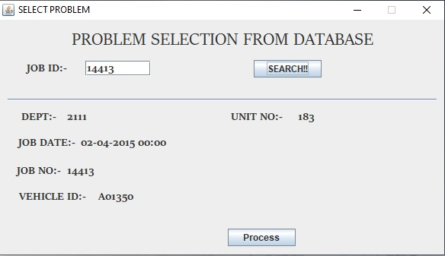
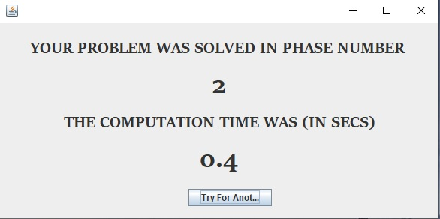
Figure 9: Select Problem Window

Figure 10: Output Window

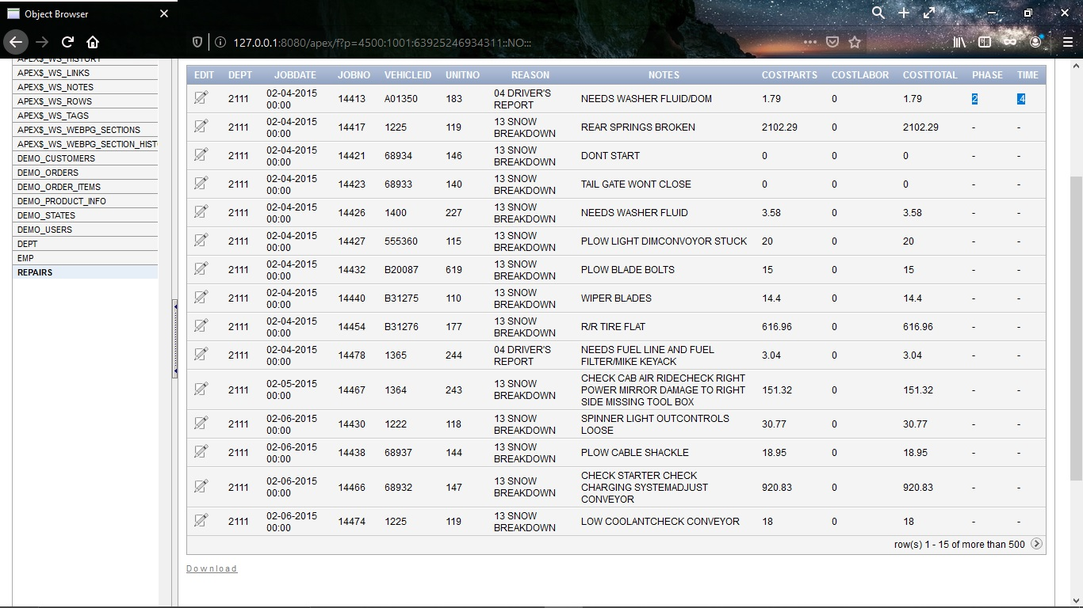
Figure 11: Updated Database

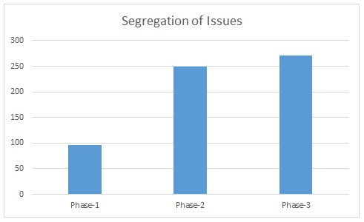
Using this self-made application and implementing the idea of our proposed system we found the following results.
Figure 12: Case wise segregation

In the above figure we see case wise segregation of problems based on our proposed system. We see 50% reduction in number of cases going to the service station.

We have used the following pseudocode:-
1. Start
2. Select a record from database based on job no
3. Check if the problem is solvable in phase 1.
4. If true update database phase column and computation time and go to step otherwise go to step 5.
5. Check if the problem is solvable in phase 2.
6. If true update database phase column and computation time and go to step otherwise go to step 7.
7. Check if the problem is solvable in phase 3.
8. If true update database phase column and computation time and go to step otherwise go to step 9.
9. Display the result.
10. Stop

6.2 Analysis
6.2.1 Phase-1
Let,
N = no. of cars in trouble in a radius of r kms. at a time instant T.
f = total no. of fellow car present at a time instant T.
p₁ = percentage of fellow car who can provide assistance to some or all of the N cars in trouble.
Hence, the no. of problems solved by fellow cars =
6.2.2 Phase-2
Let,
s = no. of service cars presents at time instant T.
r = maximum radius allowed for each car in trouble.
p₂ = percentage of service vehicles who can provide assistance to some or all of the N cars in trouble.
So, no. of problems solved by service cars =
6.2.3 Phase-3
It is obvious that unsolved issues would be handled in this phase.
Hence,
No. of problems solved by service stations = 
In case of typical system entire problem is likely to be handles by the service station.
Hence,
No. of problem solved by the service station = N
It is observed that the no. of car issues served by the service station by implementing our proposed method would be less as,  = 
6.2.4 Analytical Study of Fuel Consumption
Fuel consumption is directly proportional to the distance travelled.
6.2.4.1. Phase-1
Let,
N = no. of cars in trouble at time T.
f = no. of fellow cars presents at time instant T.
r = maximum radius allowed for each car in trouble.
p₁ = percentage of fellow vehicles who can provide assistance to some or all of the N cars in trouble.
Now, we note that the fellow cars which will provide assistance will actually travel no extra distance because fellow cars accept requests only if they find that the assistance has to be provided in to a vehicle which is on their desired route they are travelling in.
Hence, distance travelled by fellow cars to help =
6.2.4.2 Phase-2
Let,
s = no. of service cars presents at time instant T.
r = maximum radius allowed for each car in trouble.
p₂ = percentage of service vehicles who can provide assistance to some or all of the N cars in trouble.
d_{avg} = average up-down distance from service car to car in trouble. It is obvious that d_{avg}<=r.
So, distance travelled by service cars to provide assistance =
6.2.4.3 Phase-3
Unsolved issues would be directed to the service station. They are either towed or reached there by its’ own. Hence,
D_{avg} = average up-down distance from service station to car in trouble.
So, distance travelled to reach service station = 
Hence, Total distance travelled would be,
d_{edge} = d₁ + d₂ + d₃ = 
In typical cases total distance travelled by affected cars would be
d_{non-edge} =
where,
N = no. of cars in trouble at time T.
D_{avg} = average up-down distance from service station to car in trouble.
As all the affected cars would likely to be directed to service stations.
Fuel consumption would be significantly improved by implementing our proposed method as
.
d_{improved} = d_{non-edge} – d_{edge}
= 
= 
It is found that implementation of Edge Computing in car assistance in a remote highway would be advantageous in many aspects. Amount of issues directed to the service station would be significantly less that yields manpower savings. Fuel consumption would also be significantly less as a substantial amount of issues would be resolved by the fellow vehicles or service cars.

7. CONCLUSION

A Vehicle Emergency Support System is proposed in this project to reduce the expenditure in terms of human resource and fuel consumption. Here vehicle issues are initially communicated and taken care by the passing by vehicles. In the next phase issues would be redirected to the service cars directly. In both cases it is presumed that supporting vehicles need to travel minimum distance. Hence fuel consumption would be minimum. Rest pf the unsolved issues would be handles by the service station. It is observed based on the real time data set that more than 50% issues would be resolved by the fellow vehicles or service cars. It is definitely advantageous over the typical system that need the entire issues at service station and then analyze and decide centrally.
This assistance system can of great help in case of autonomous vehicle systems. Here the cars are meant to be autonomous and in case they need assistance they call for assistance in an autonomous way. They call for help to the servers. In case of mass failure of autonomous cars, the servers will have a lot of pressure on itself. Then edge computing comes to the rescue. We filter the problem at two levels at the edge of the network. First with other autonomous vehicles then with service cars.
The time taken to solve the problem using this autonomous system is considerably lesser than a manual approach or a GPRS enabled approach where we search for nearest assistance center in the web.
We can say that our conventional assistance system is much more helpful due to its autonomous properties. Due to reduced human interaction the entire process speed increases by many times.
Edge computing makes the entire process faster by filtering the entire process into multiple levels and reduces unnecessary pressure on the upper layers. It is best suited in situations where human interaction takes a lot of time or is impossible to occur.
Keeping all these factors in mind we conclude that our system ‘Vehicle Emergency Support System’ is a much enriched and better idea.

REFERENCES
[1] Inés Sittón-Candanedo, Juan Manuel Corchado Rodríguez, “An Edge Computing Tutorial”. Oriental Journal of Computer Science and Technology, ISSN: 0974-6471, Vol. 12, No. (2) 2019, Pg. 34-38.
[2] Xia X. et al. (2019) “Graph-Based Optimal Data Caching in Edge Computing”. In: Yangui S., Bouassida Rodriguez I., Drira K., Tari Z. (eds) Service-Oriented Computing. ICSOC 2019. Lecture Notes in Computer Science, vol 11895. Springer, Cham
[3] H Najmul, Y Kok-lim Alvin, CELIMUGE WU, “Edge Computing in 5G: A Review”. IEEE Access 10.1109/ACCESS.2019.2938534.
[4] B Ivan,H Stephen,L Nigel,P O’Brien,W Keith, “Multi Access Edge Computing”. ITP Journal EDITORIAL (Vol. 12, Part 3) July - September 2018.
[5] Premsankar G., Di Francesco M. & Taleb T. “Edge Computing for the Internet of Things: A Case Study.” IEEE Internet Things J. 5, 1275–1284 (2018).
[6] Yuan Ai, Mugen Peng, Kecheng Zhang, “Edge computing technologies for Internet of Things: a primer”, Digital Communications and Networks, ScienceDirect, Volume 4, Issue 2, pp. 77-86, 2018.
[7] Eric Hamilton, “What is Edge Computing: The Network Edge Explained”, cloudwards.net, 2018.
[8] Tuyen X. Tran, Mohammad-Parsa Hosseini, Dario Pompili, “Mobile Edge Computing: Recent Efforts and Five Key Research Directions”, IEEE COMSOC Communications-Frontiers, Volume 12, Issue 4, pp. 29-33, 2017
[9] Satyanarayanan M. The “Emergence of Edge Computing.” Computer (Long. Beach. Calif). 50, 30–39 (2017).
[10] El-Sayed H., Sankar S., Prasad M., Puthal D., Gupta A., Mohanty M. and Lin C.T. “Edge of Things: The Big Picture on the Integration of Edge, IoT and the Cloud in a Distributed Computing Environment.” IEEE Access 6, 1706–1717 (2017).
[11] Xiang Sun, Nirwan Ansari, “EdgeIoT: Mobile Edge Computing for the Internet of Things”, IEEE Communications Magazine, Volume 54, Issue 12, pp. 22-29, 2016.
[12] Wenlu Hu, Ying Gao, Kiryong Ha, Junjue Wang, Brandon Amos Zhuo Chen, Padmanabhan Pillai, Mahadev Satyanarayanan, “Quantifying the Impact of Edge Computing on Mobile Applications”, APSys’16, Hong Kong, 2016.
[13] Varghese B., Wang N., Barbhuiya S., Kilpatrick P. & Nikolopoulos D.S. “Challenges and Opportunities in Edge Computing.” Proc. - 2016 IEEE Int. Conf. Smart Cloud.
[14] Kyudong Park, Jiyoung Kwahk, Sung H. Han, Minseok Song, Dong Gu Choi, Hyeji Jang, Dohyeon Kim, Young Deok Won, In Sub Jeong, “Modelling the Intrusive Feelings of Advanced Driver Assistance Systems Based on Vehicle Activity Log Data: Case Study for the Lane Keeping Assistance System”, International Journal of Automotive Technology, Volume 20, pp. 455-463, 2019.
[15] Vipin Kumar Kukkala, Jordan Tunnell, Sudeep Pasricha, Thomas H Bradley, “Advanced Driver-Assistance System: A Path Toward Autonomous Vehicles”, IEEE Consumer Electronics Magazine, Volume 7, Issue 5, pp. 18-25, 2018.
[16] Miss. K. Iswarya, Miss. D. Devaki,Mr. E. Ranjith,” Road Assistance System Using GPS.” IJARIIT, 2017,ISSN: 2454-132X Impact factor: 4.2 95 (Volume3, Issue2)

[17]Khoo Jin Sheng, Ahmad Suhaimi Baharudin, Kamal Karkonasasi,” A Car Breakdown Service Station Locator System.” International Journal of Applied Engineering Research ISSN 0973-4562 Volume 11, Number 22 (2016) pp. 11037-11040
[18] M. Rohani, R. Buhari, B. David Daniel, J. Prestijo, K. Ambak, N. Abd Sukor and S. A. Hasan, “Car Driving Behaviour on Road Curves: A Study Case in Universiti Tun Hussein Onn Malaysia,” Applied Mechanics and Materials, Vol. 773-774, pp. 990-995, Jul. 2015.
[19] Yimin Zhou, Gang Wang, Guoqing Xu, Guoqiang Fu, “Safety driving assistance system design in intelligent vehicle”, IEEE International Conference on Robotics and Biomimetrics (ROBIO 2014), Bali, Indonesia, 2014
[20] Saravanan Kannan, Arunkumar Thangavelu, RameshBabu Kalivaradhan, “An Intelligent Driver Assistance System (I-DAS) for Vehicle Safety Modelling using Ontology Approach”, International Journal of UbiComp, Volume 1, Issue 3, pp.15-29, 2010
[21] R. Soemitro and Y. Bahat, “Accident Analysis Assessment to The Accident Influence Factors on Traffic Safety Improvement (Case : Palangka Raya Tangkiling National Road)” Proceedings of the Eastern Asia Society for Transportation Studies, vol. 5, pp. 2091 -2105, 2005.

